MACHINE LEARNING

Q1 to Q11

**1. Which of the following methods do we use to find the best fit line for data in Linear Regression?**

A) Least Square Error B) Maximum Likelihood

C) Logarithmic Loss D) Both A and B

**Answer:** A. Regression analysis uses “ least squares method” to generate best fitting line.

**2. Which of the following statement is true about outliers in linear regression?**

A) Linear regression is sensitive to outliers B) linear regression is not sensitive to outliers

C) Can’t say D) none of these

**Answer:** A. Sum of squared residuals is sensitive to outliers. So Linear Regression is sensitive to outliers.

**3. A line falls from left to right if a slope is ______?**

A) Positive B) Negative

C) Zero D) Undefined

**Answer:** B. When a line falls from left to right when it has negative value.

**4. Which of the following will have symmetric relation between dependent variable and independent**

**variable?**

A) Regression B) Correlation

C) Both of them D) None of these

**Answer:** B. The relationship is symmetric between dependent variable and independentin case of correlation but in case of regression it is not symmetric.

**5. Which of the following is the reason for over fitting condition?**

A) High bias and high variance B) Low bias and low variance

C) Low bias and high variance D) none of these

**Answer:** C. The ideal model which overfit is most likely to have low bias and high variance.

**6. If output involves label then that model is called as:**

A) Descriptive model B) Predictive modal

C) Reinforcement learning D) All of the above

**Answer:** B. Predictive model involves label as output.

**7. Lasso and Ridge regression techniques belong to _________?**

A) Cross validation B) Removing outliers

C) SMOTE D) Regularization

**Answer:** D. Lasso and Ridge regression techniques belong to regularization which is used to reduce model complexity and prevent overfitting.

**8. To overcome with imbalance dataset which technique can be used?**

A) Cross validation B) Regularization

C) Kernel D) SMOTE

**Answer: C.**

**9. The AUC Receiver Operator Characteristic (AUCROC) curve is an evaluation metric for binary**

**classification problems. It uses _____ to make graph?**

A) TPR and FPR B) Sensitivity and precision

C) Sensitivity and Specificity D) Recall and precision

**Answer:** A. Roc curve is plotted with TPR against FPR where TPR is on the Y-axis and FPR is on the X-axis.

**10. In AUC Receiver Operator Characteristic (AUCROC) curve for the better model area under the**

**curve should be less.**

1. True B) False

**Answer:** A.

**11. Pick the feature extraction from below:**

A) Construction bag of words from a email

B) Apply PCA to project high dimensional data

C) Removing stop words

D) Forward selection

**Answer:** A, B & C

Q12

**12. Which of the following is true about Normal Equation used to compute the coefficient of the Linear Regression?**

A) We don’t have to choose the learning rate.

B) It becomes slow when number of features is very large.

C) We need to iterate.

D) It does not make use of dependent variable.

**Answer:** A, B & C

**Q13 to Q15**

13. Explain the term regularization?

**Answer:** The term ‘regularization’ refers to a set of techniques that regularizes learning from particular features for traditional algorithms and It normalizes and moderates weights attached to a feature so that algorithms do not rely on just a few features to predict the result. This technique helps to avoid the problem of overfitting.

14. Which particular algorithms are used for regularization?

**Answer:** There are three main regularization techniques which are as follows:

1. **Ridge Regression (L2 regularization) :** Ridge regression is also called L2 norm or regularization. When using this technique, we add the sum of weight’s square to a loss function and thus create a new loss function. the original loss function is modified by adding normalized weights. Where normalized weights are in the form of squares.

**Expression:**

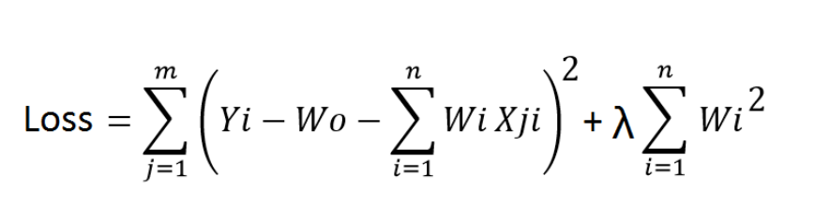

1. **Lasso Regression (L2 regularization) :** Lasso regression is also called L1 norm or regularization. This technique is different from ridge regression as it uses absolute weight values for normalization. λ is again a tuning parameter and behaves in the same as it does when using ridge regression. As loss function only considers absolute weights, optimization algorithms penalize higher weight values. In ridge regression, loss function along with the optimization algorithm brings parameters near to zero but not actually zero, while lasso eliminates less important features and sets respective weight values to zero. Thus, lasso also performs feature selection along with regularization.

**Expression:**

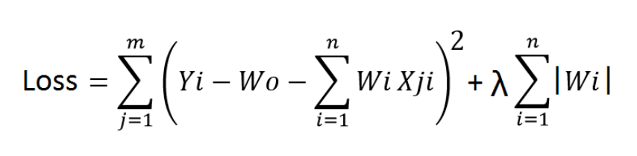

15. Explain the term error present in linear regression equation?

**Answer:** A Linear Regression model’s main aim is to find the best fit linear line and the optimal values of intercept and coefficients. The best fit line predicted by the model i.e the predicted values lie on that line and the actual value might have some difference in between and the vertical distance between the data point and the best fit line is known as residual or error.

**Mathematical Approach:**

Residual/Error = Actual values – Predicted Values

Sum of Residuals/Errors = Sum(Actual- Predicted Values)

Square of Sum of Residuals/Errors = (Sum(Actual- Predicted Values))2